**Authentication Page**

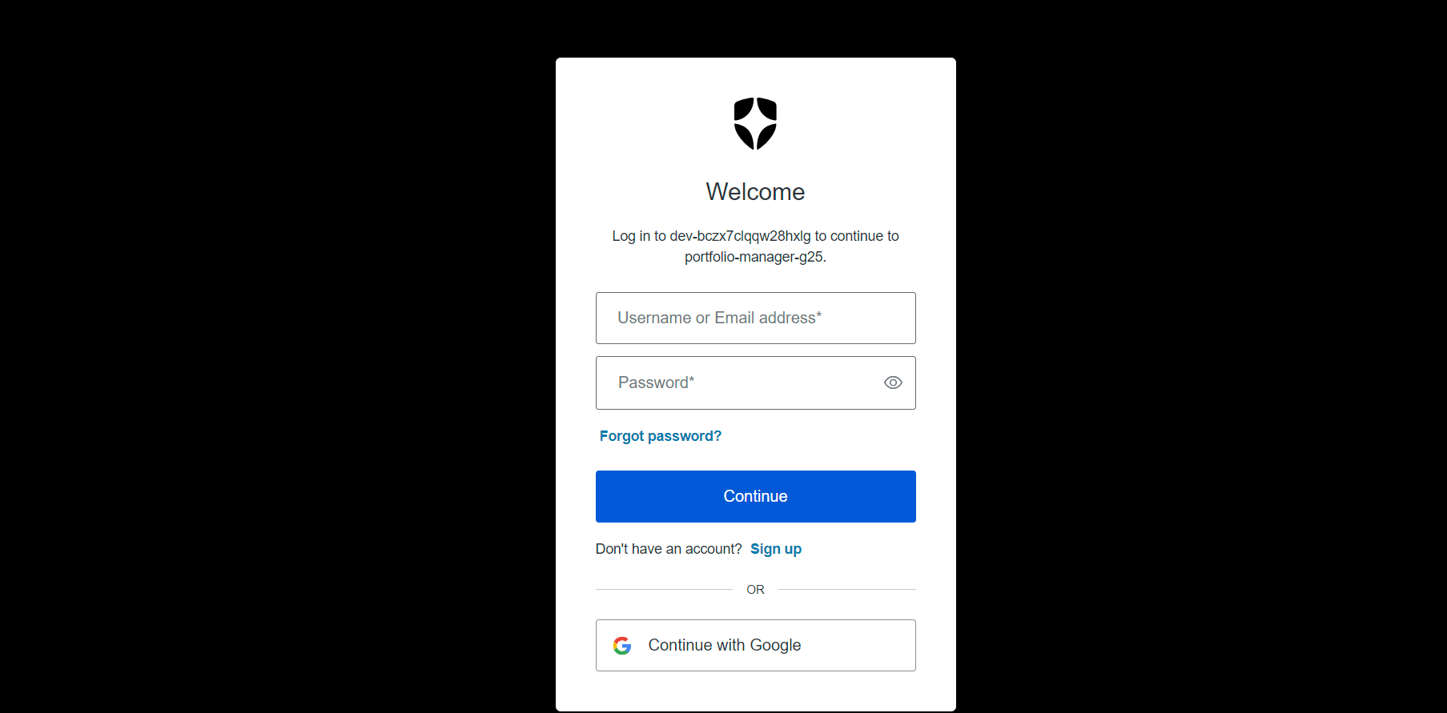

Buttons

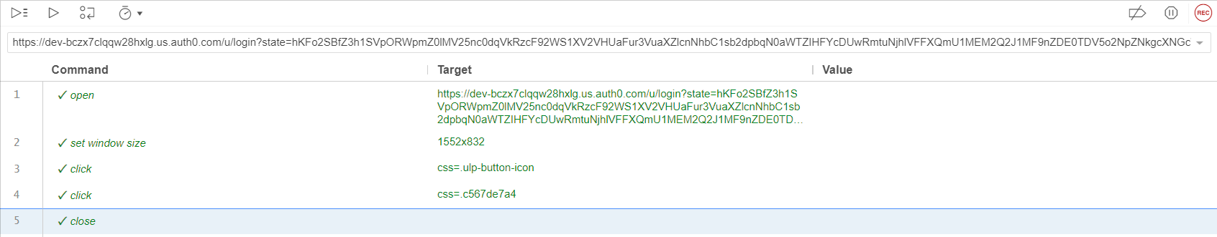

Textbox

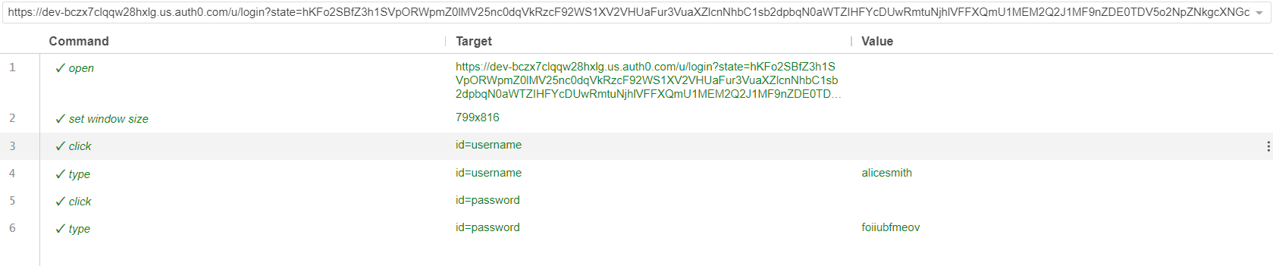

Links – Forgot Password

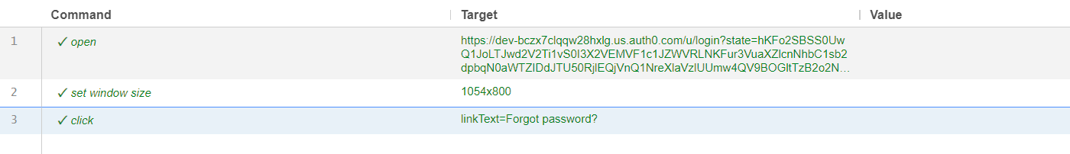

Link – SignUp

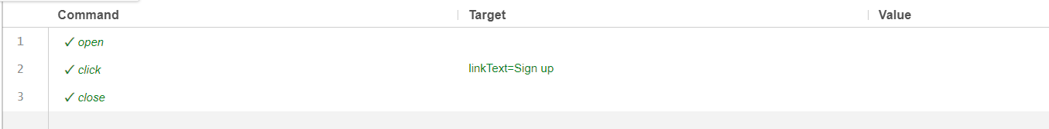

Link – Continue with Google

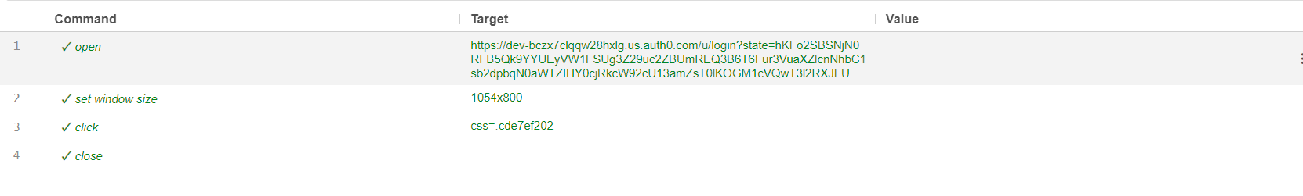

Signup Page

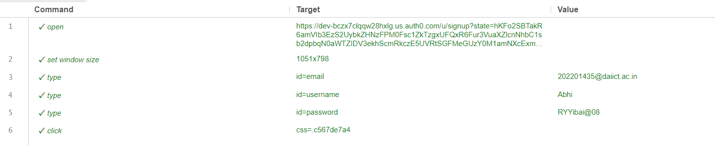

**Profile Page**

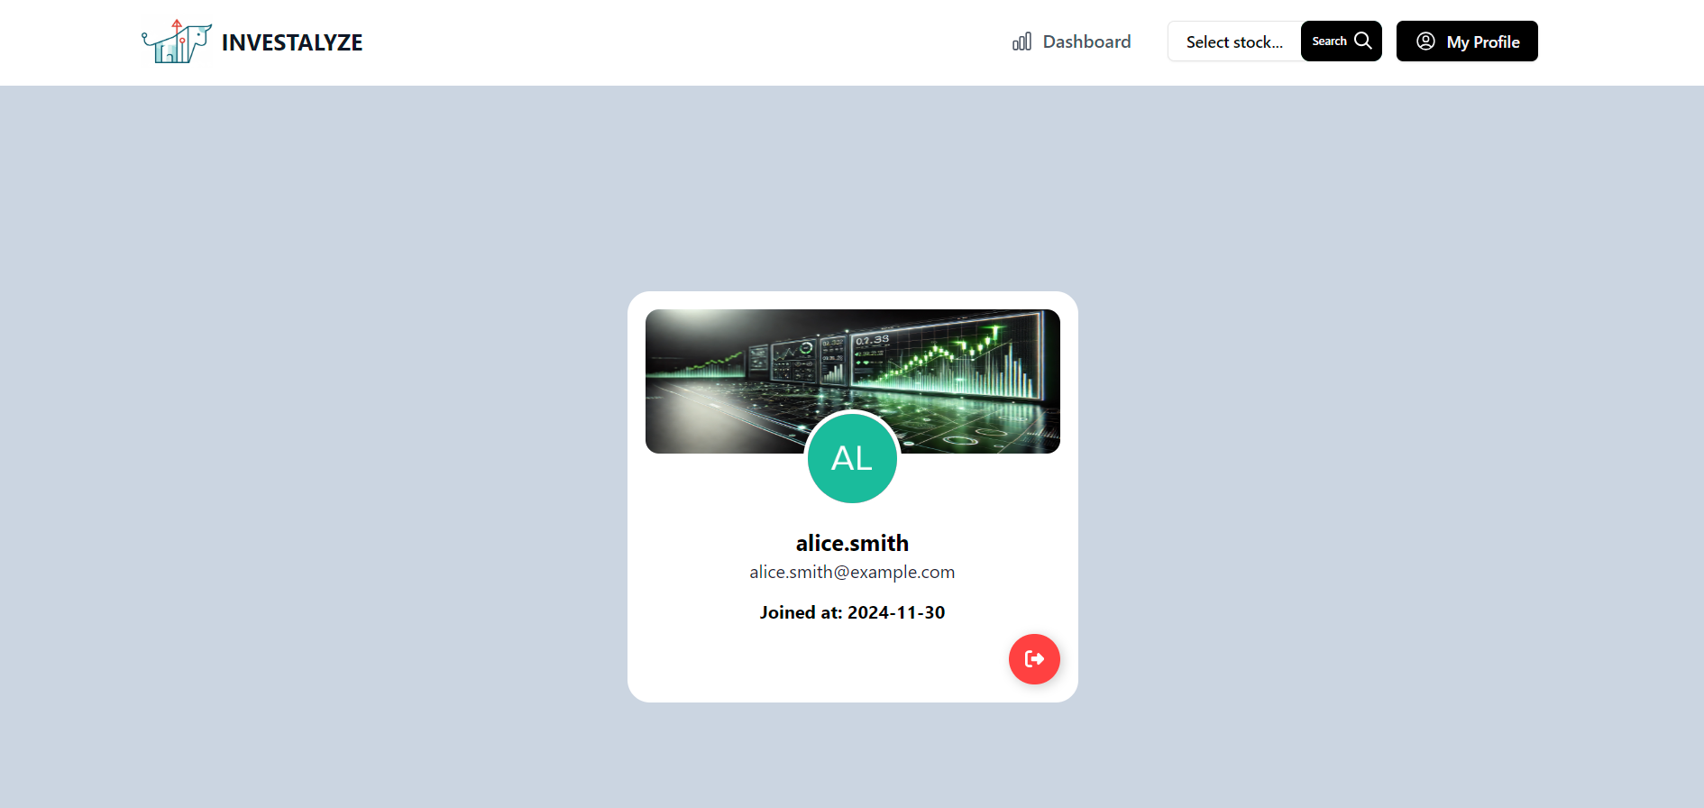

Logout

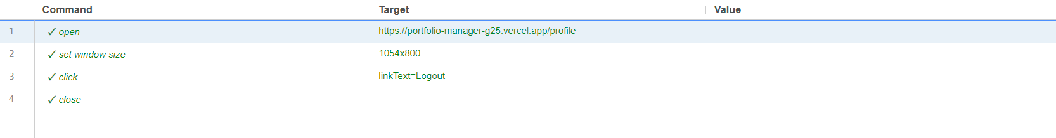

Link – StockInfo

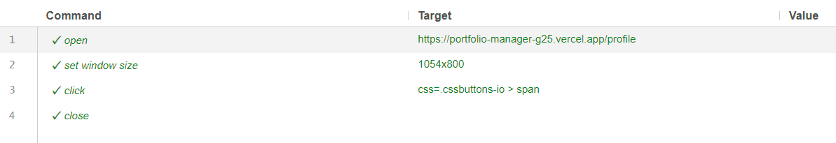

Link – MyProfile

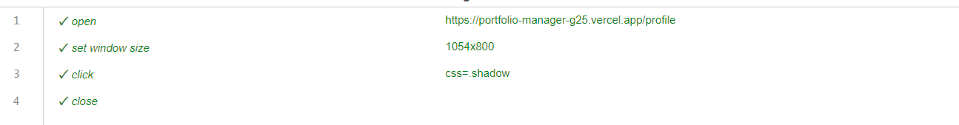

Link – Dasboard

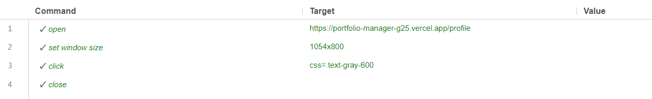

Stock Search – Scroll and Click

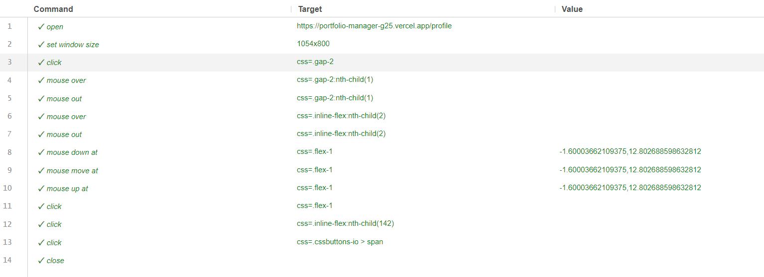

TextBox – Stock Search

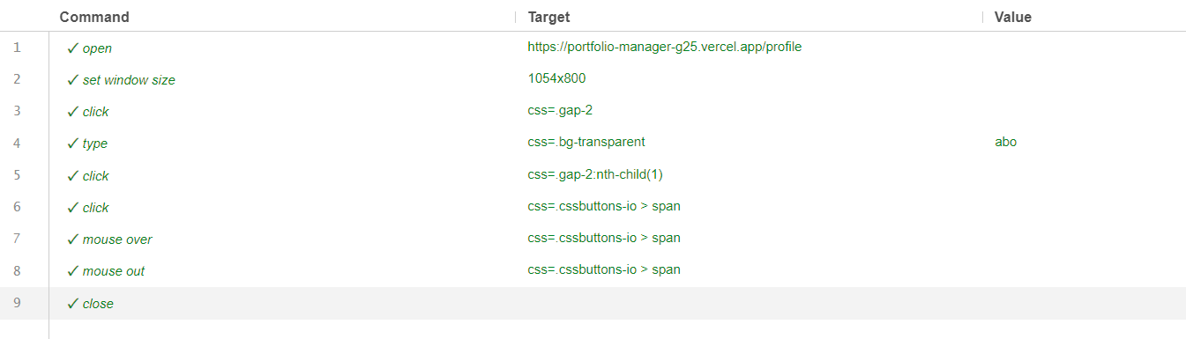

**Login Page**

Link – Login

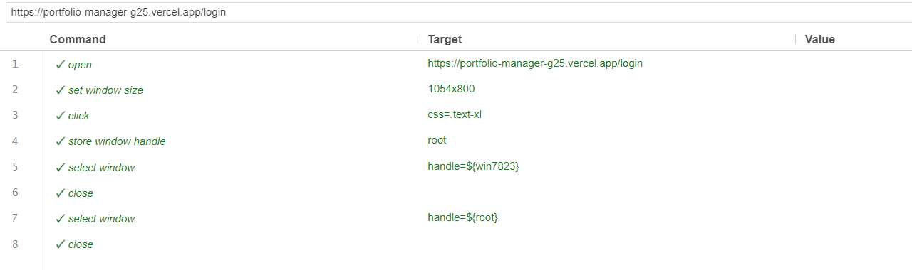

**Dashboard Page**

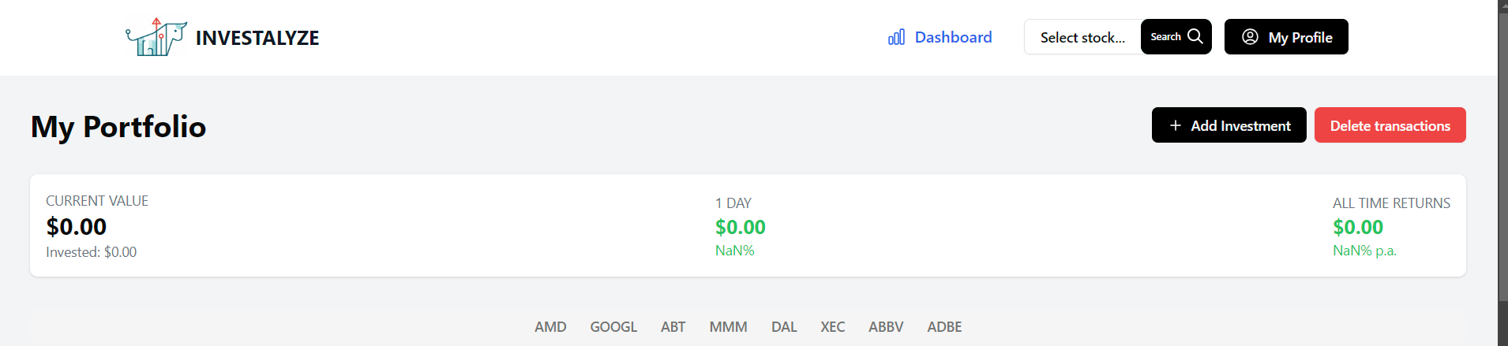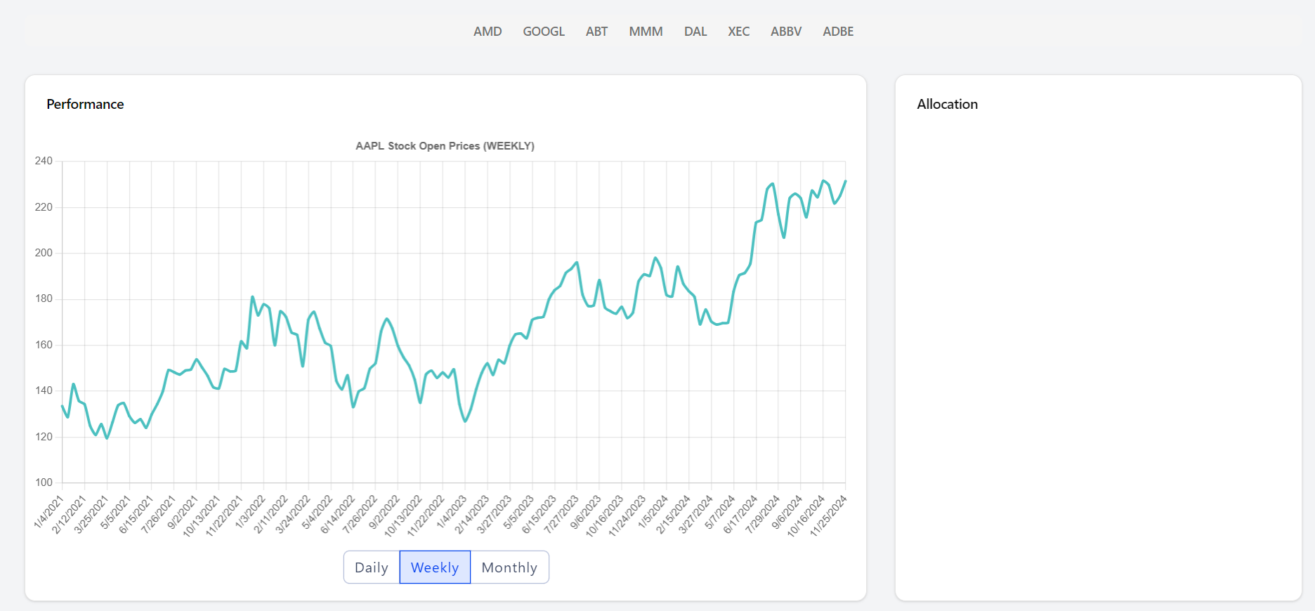

Button – Add Investment

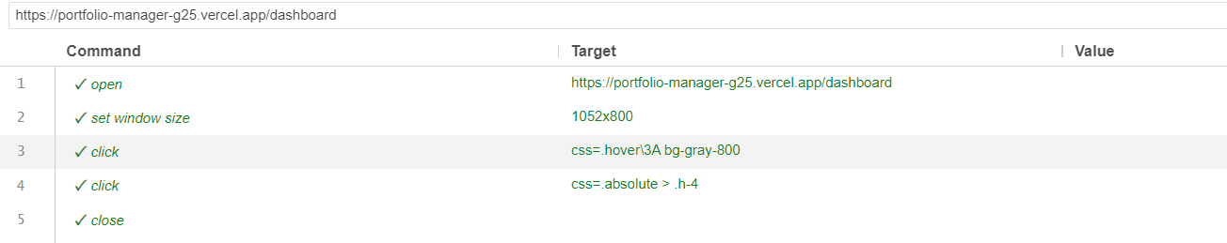

Button – Delete Investment

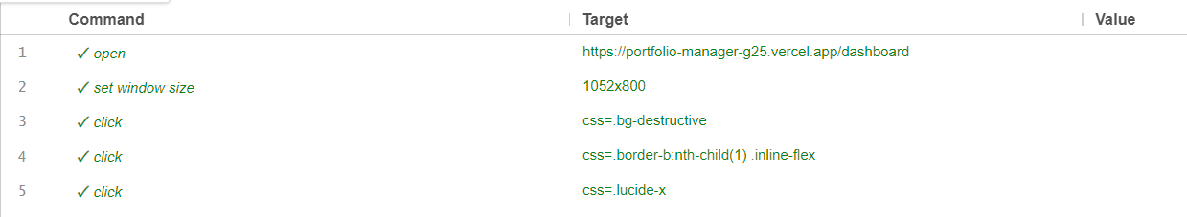

Button – Graph Buttons

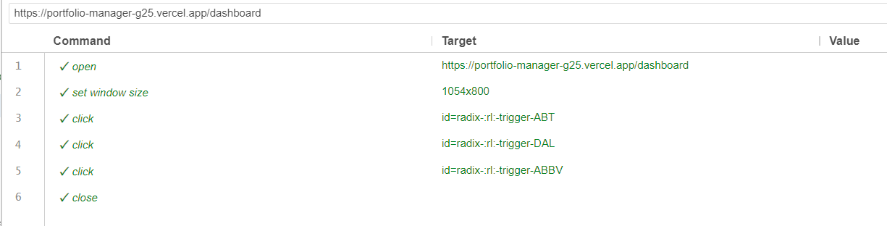

Link – Dashboard

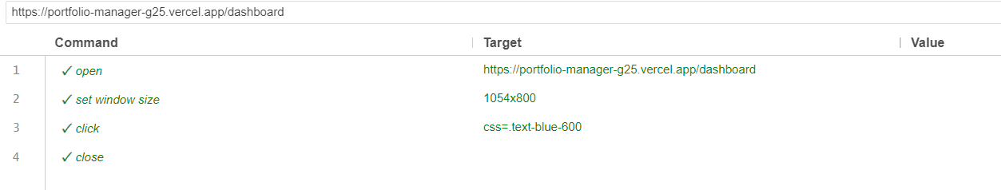

Link – MyProfile

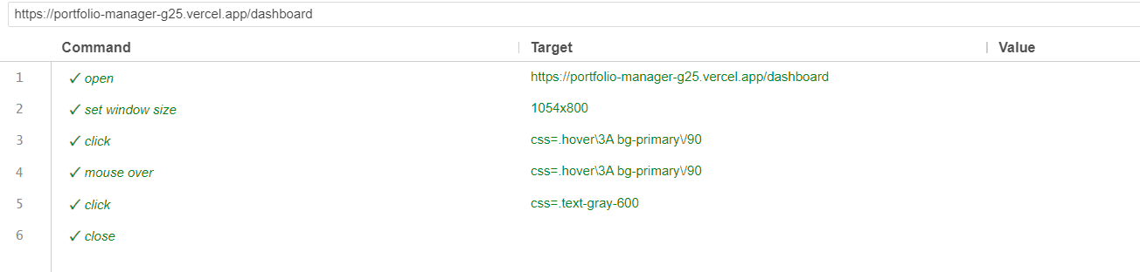

Link – StockInfo

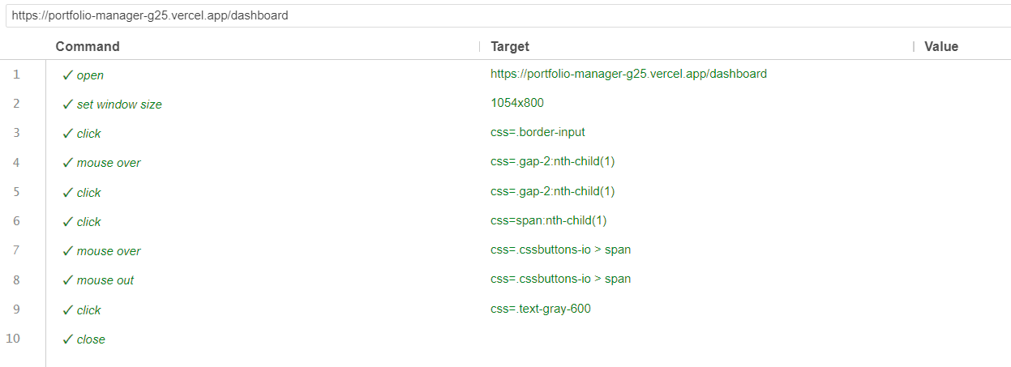

Scroll and Click – Stock Search

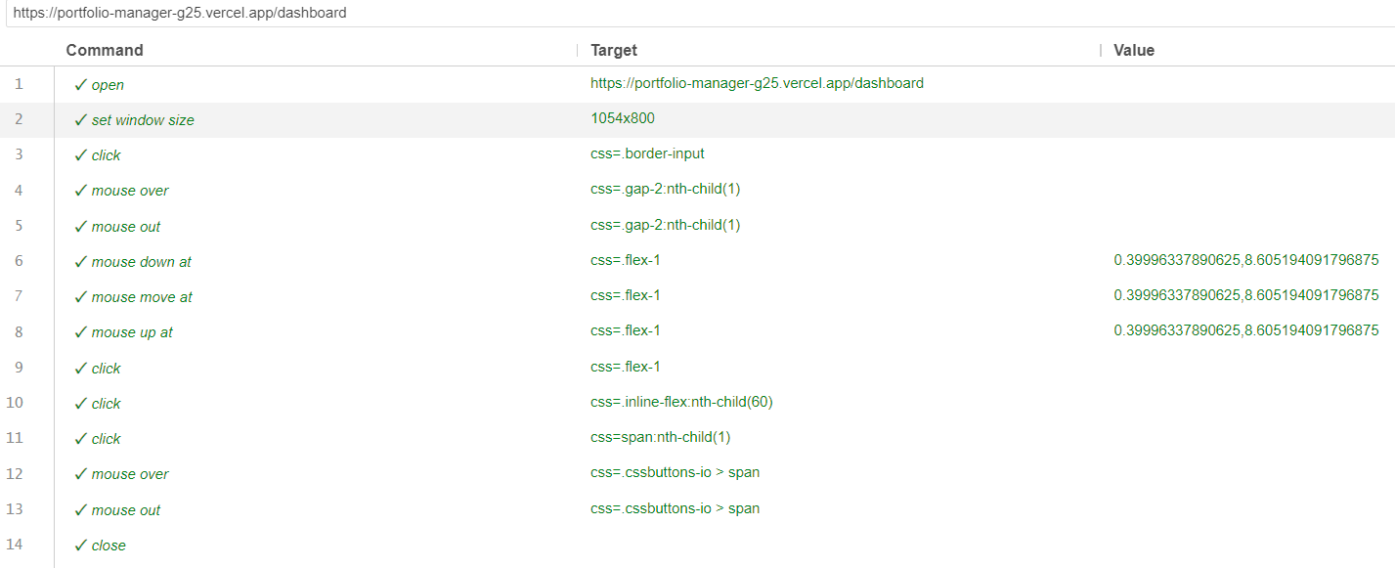

TextBox – StockSearch

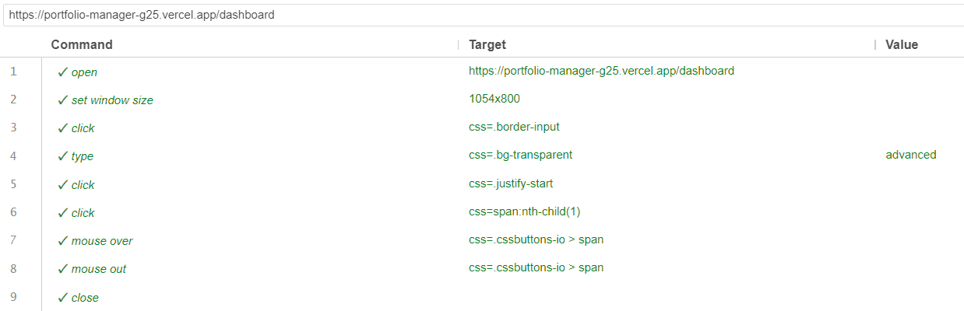

TextBoxes and Buttons – In Add Investment

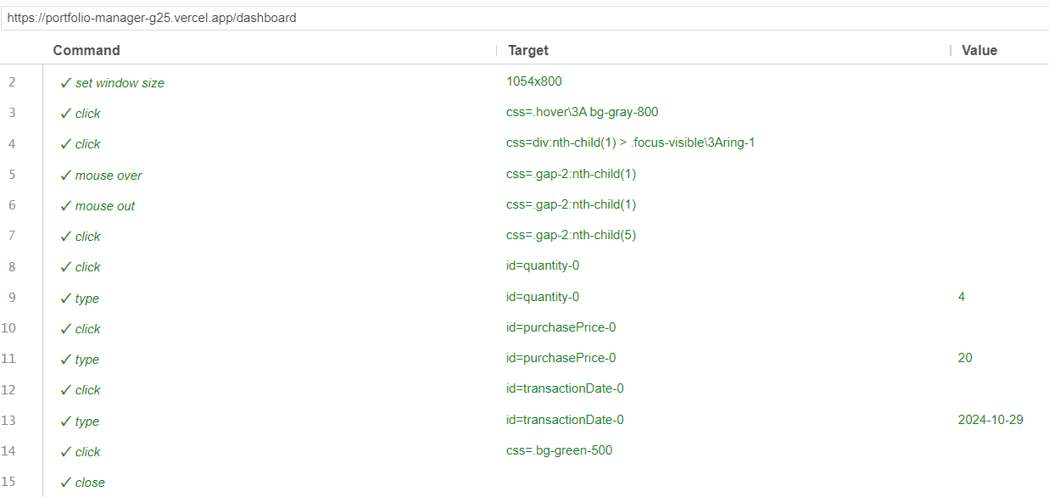

Button – Daily/Weekly/Monthly Buttons in Graph

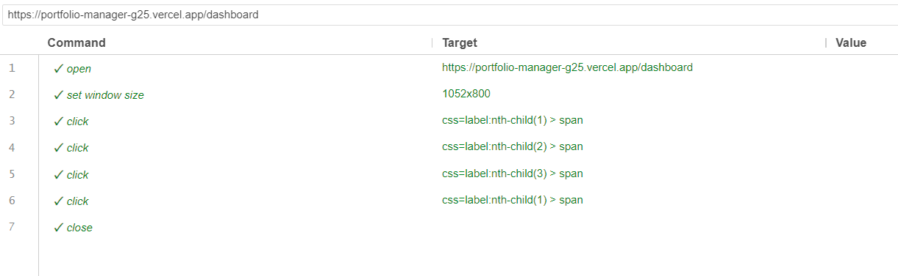

**StockInfo Page**

Since we have already tested Dashboard, Stock Search and My Profile Links twice in the dashboard and profile page we will not test it here.

Also, Since StockInfo Page is for particular page, we will test on this for a particular stock.

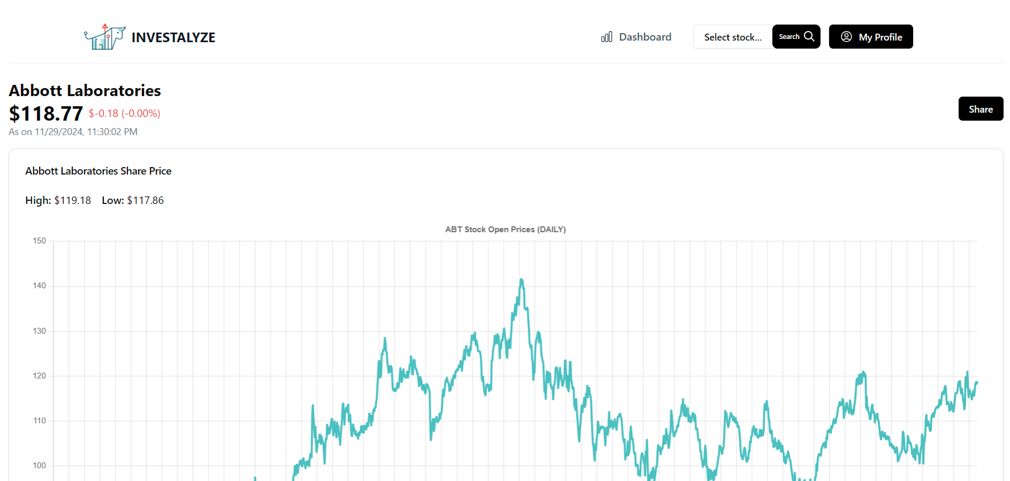 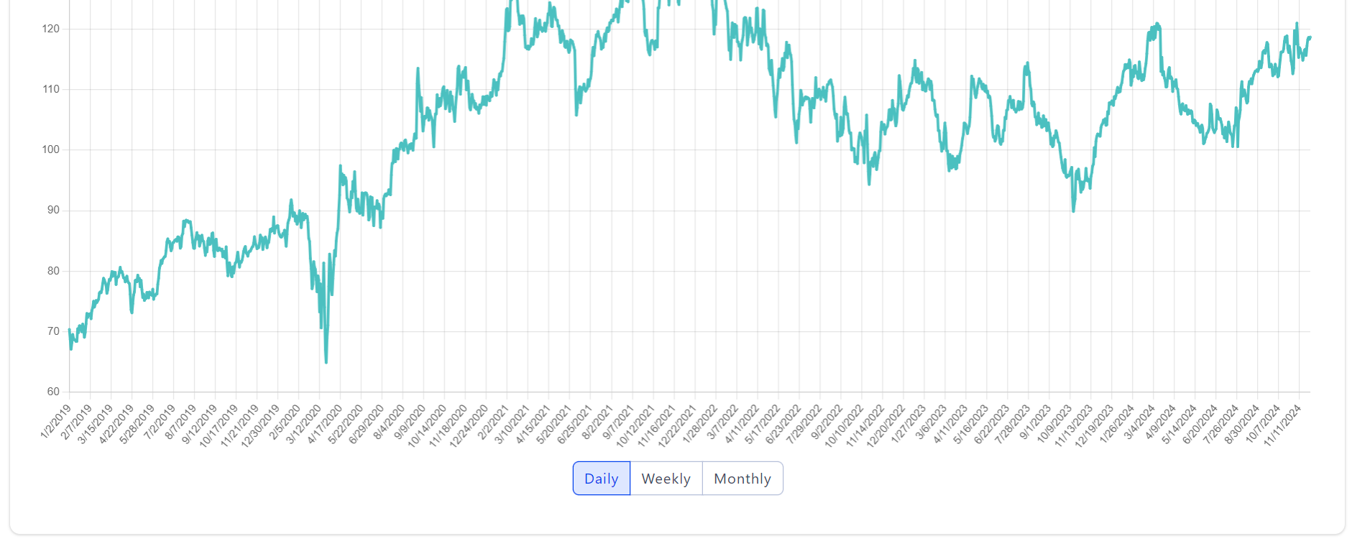 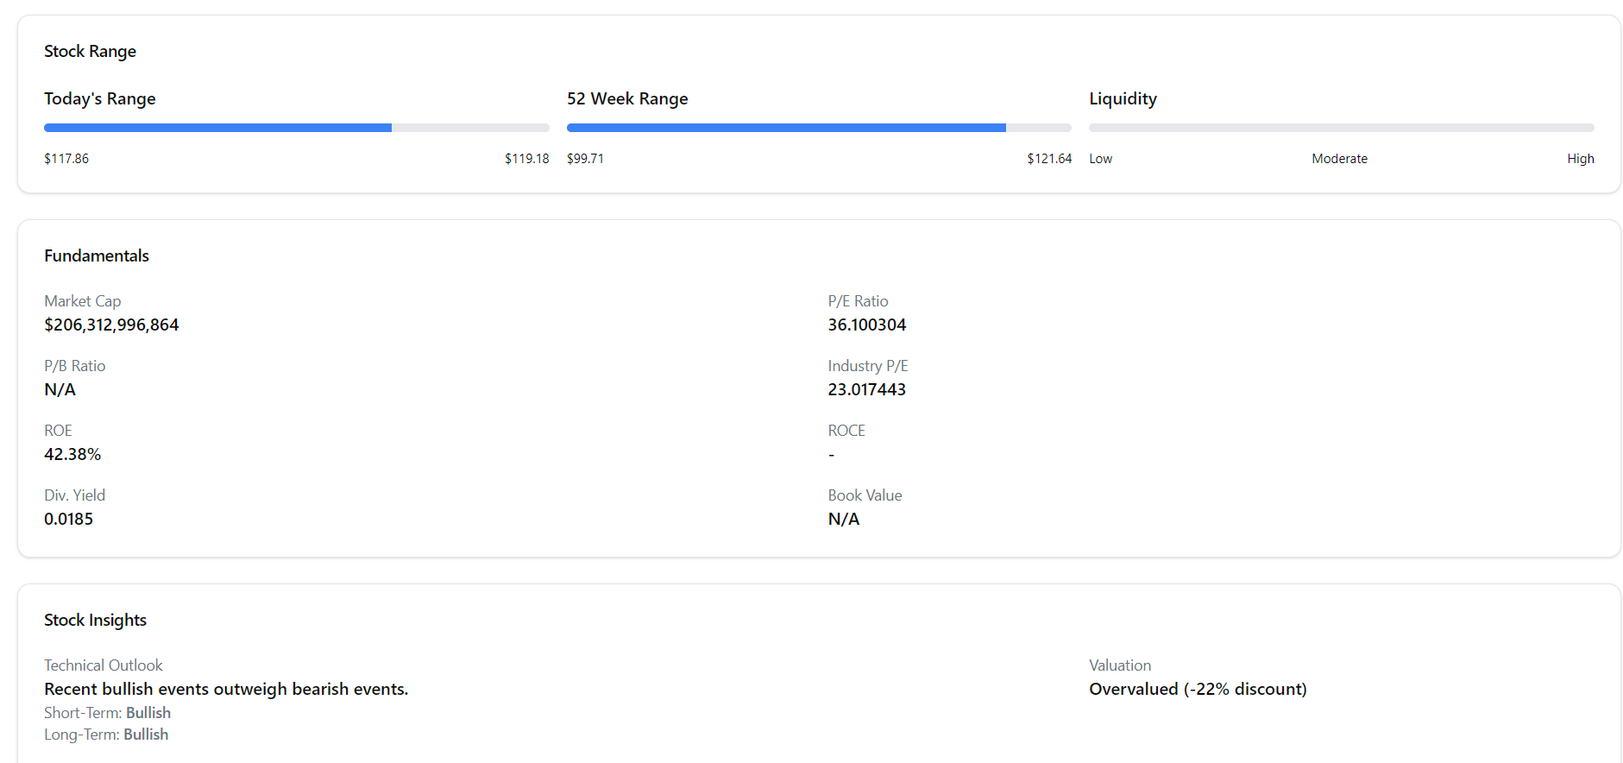 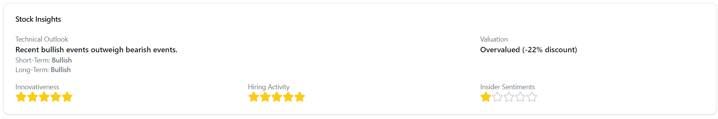 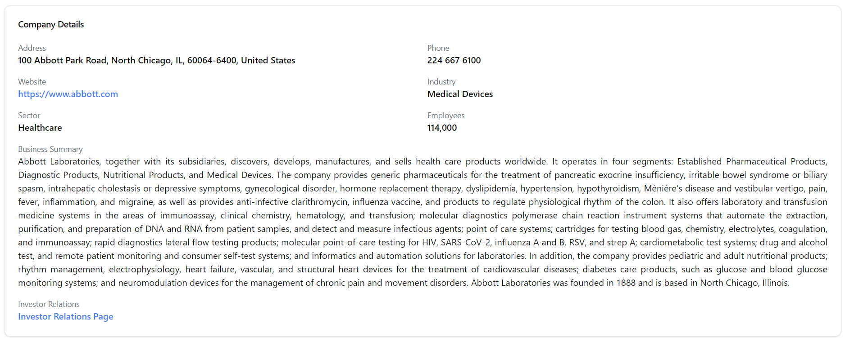

Button – Daily/Weekly/Monthly Button in Graph

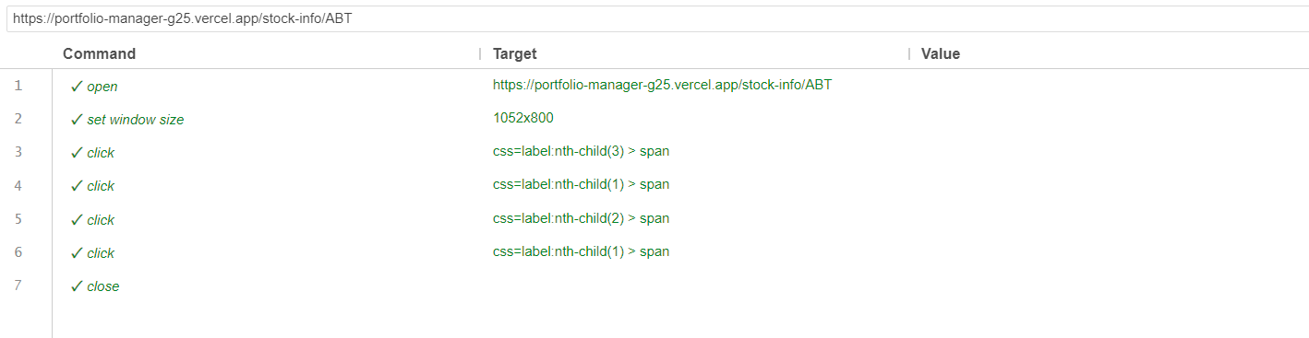

Link – Company Website

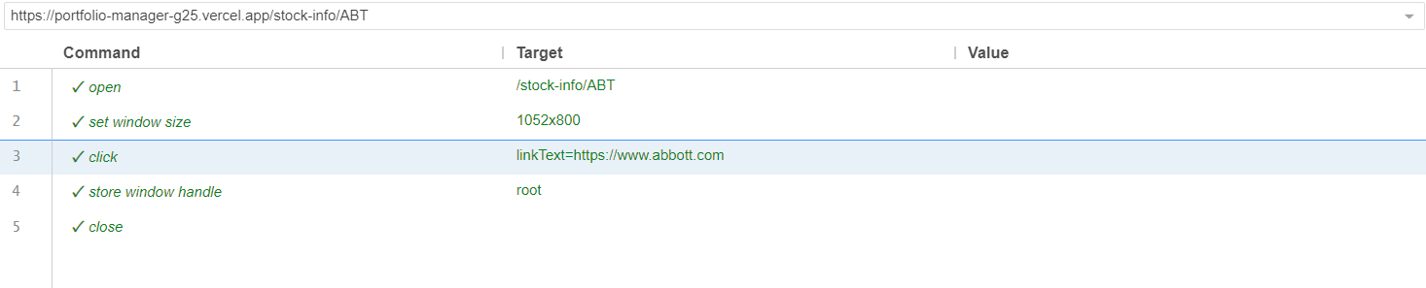

Link – Investors Relation Page

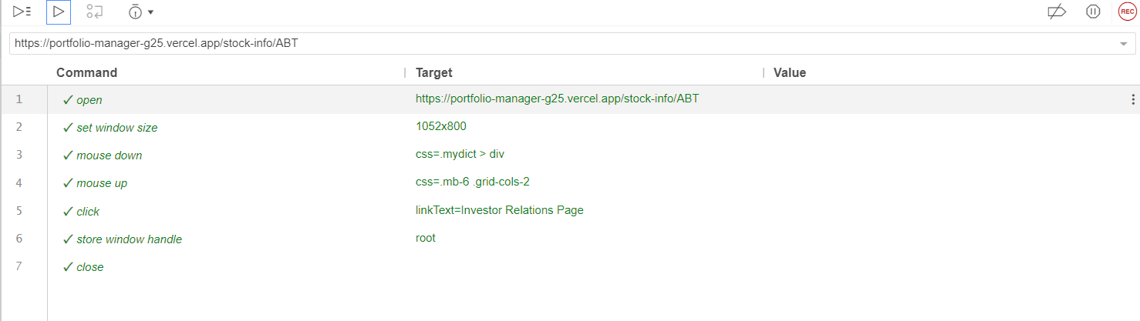

Button – Copy Link of the Page

